290320 FMH Worship

1 Cor 7:17-24

Ascribed Honour vs Achieved Honour eg royalty vs NBA star.

Lebron James broke the royal protocol by putting his arms over the Dutchess.

The theme of honour and shame still runs through Corinthians.

Status-Conscious People

* Overpopulation was always a problem. They put the freed slaves in Corinth to alleviate overcrowding of Rome.
* Aristocracy of Wealth preceded the Aristocracy of Royal Lineage.

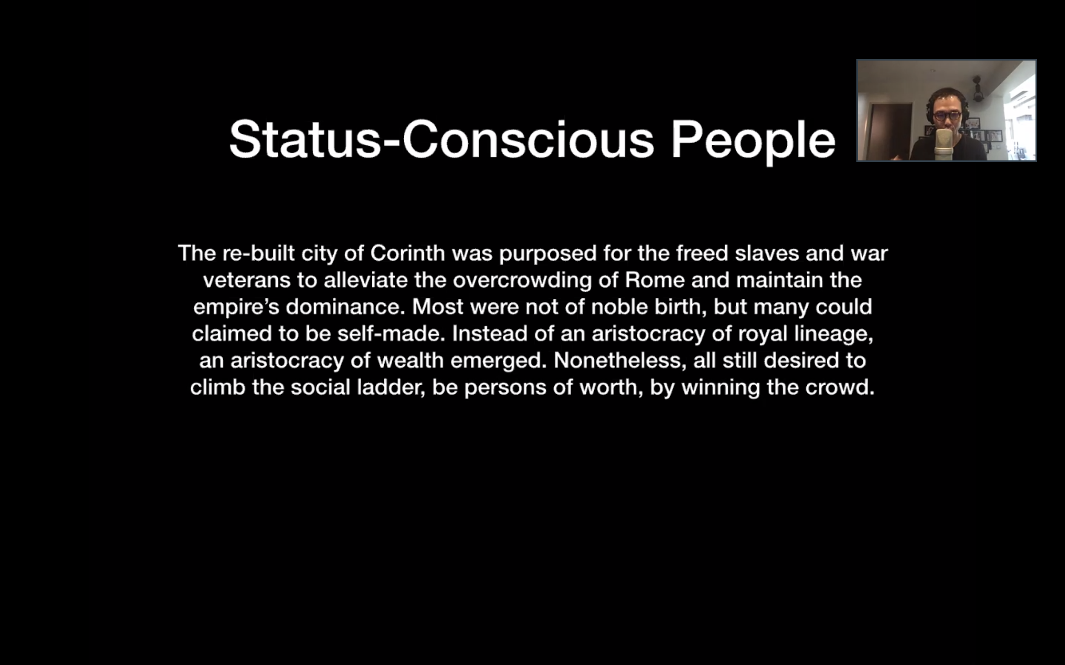

How to achieve more honour?

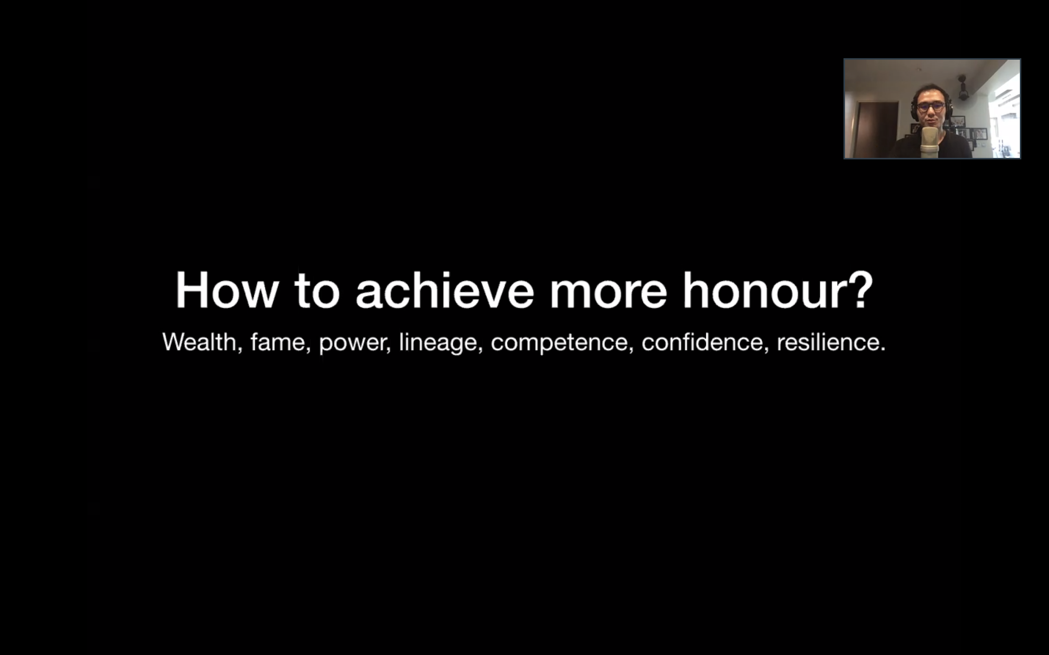

* Corinth is a city of achieved honour

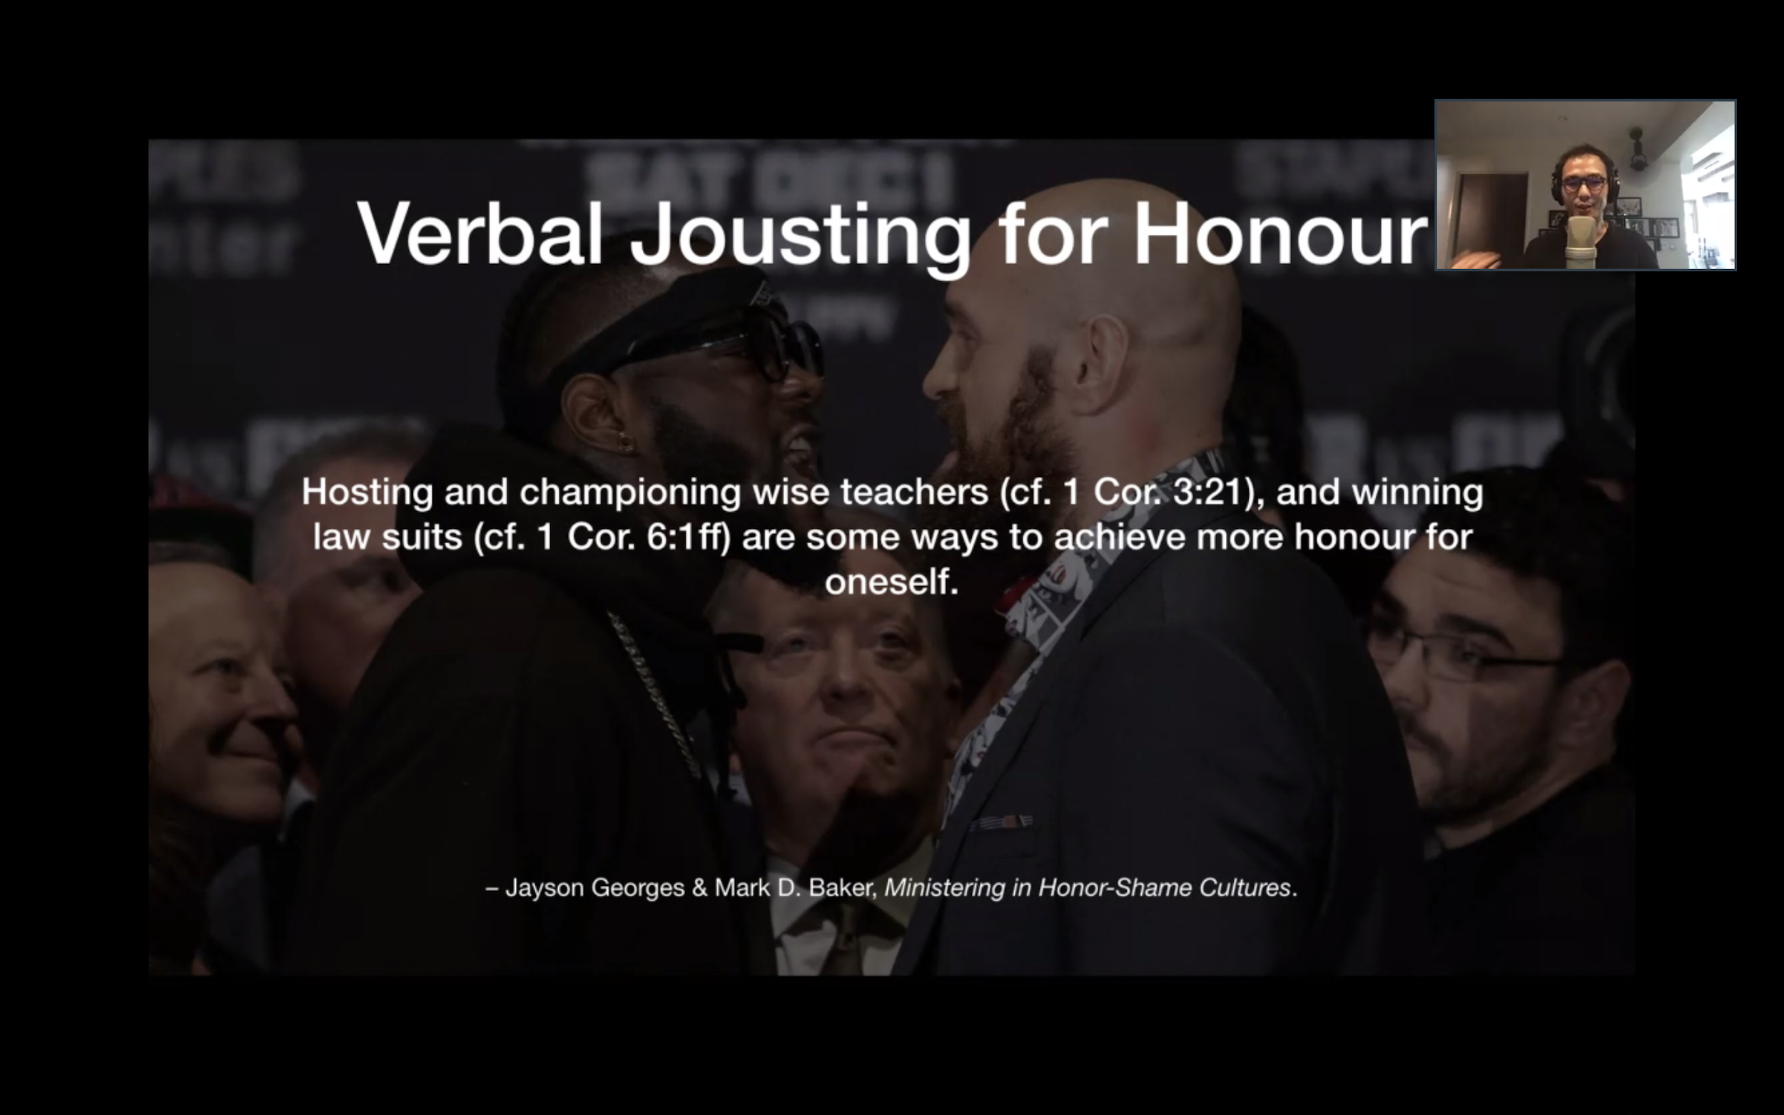

* Whenever someone wins an argument, you gain 1 unit of honour.
* As if the honour from the wise teacher spilt onto you. They gained honour through lawsuits

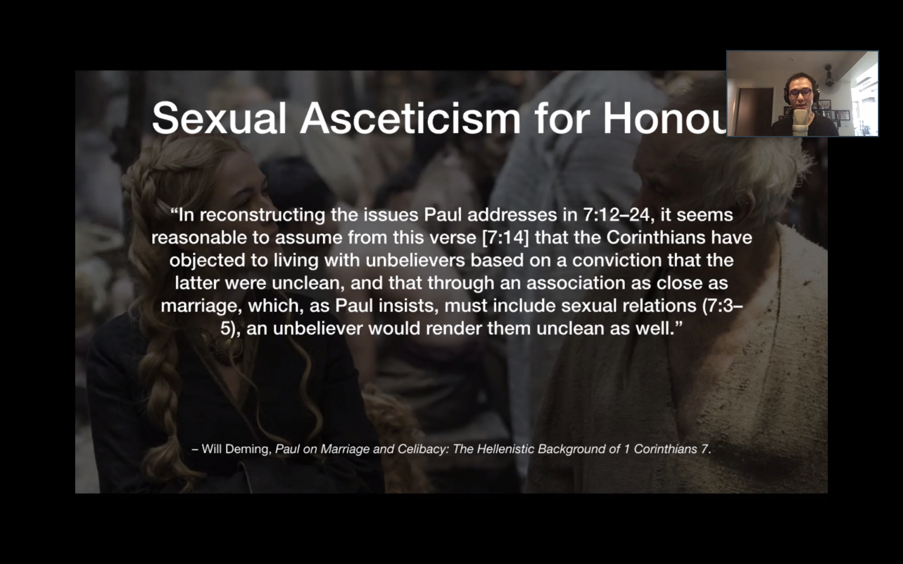

* Practicing Asceticism to gain honour as a Christian.
* “I am more honourable because I am willing to withhold myself from sexual relations.”
* People gain honour by pushing it to the extreme. Avoiding sexual relations to gain honour.

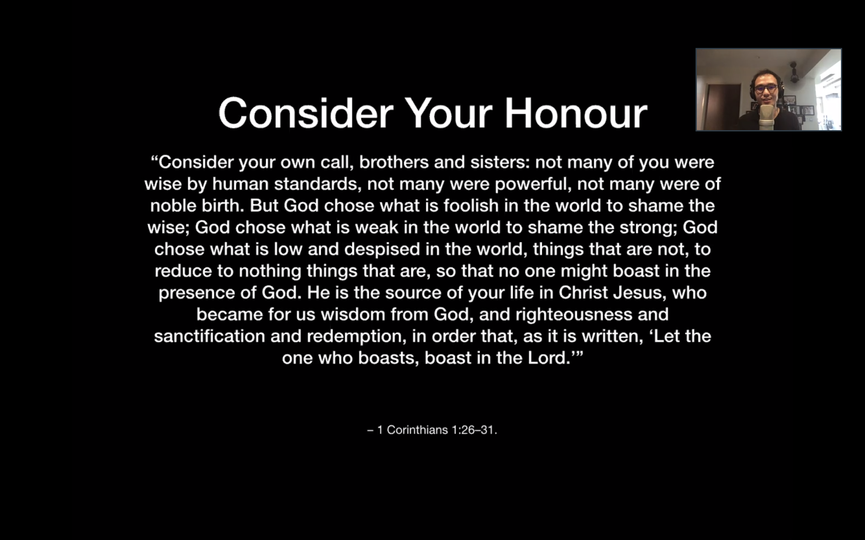

* Consider who you are.
* None of you have ascribed honour. Reminder of 3&4.
* So that we can boast in the Lord.

**1 Corinthians 7:17-24 English Standard Version (ESV)**

Live as You Are Called

17 Only let each person lead the life[a] that the Lord has assigned to him, and to which God has called him. This is my rule in all the churches. 18 Was anyone at the time of his call already circumcised? Let him not seek to remove the marks of circumcision. Was anyone at the time of his call uncircumcised? Let him not seek circumcision. 19 For neither circumcision counts for anything nor uncircumcision, but keeping the commandments of God. 20 Each one should remain in the condition in which he was called. 21 Were you a bondservant[b] when called? Do not be concerned about it. (**But if you can gain your freedom, avail yourself of the opportunity**.) 22 For he who was called in the Lord as a bondservant is a freedman of the Lord. Likewise he who was free when called is a bondservant of Christ. 23 You were bought with a price; do not become bondservants of men. 24 So, brothers,[c] in whatever condition each was called, there let him remain with God.

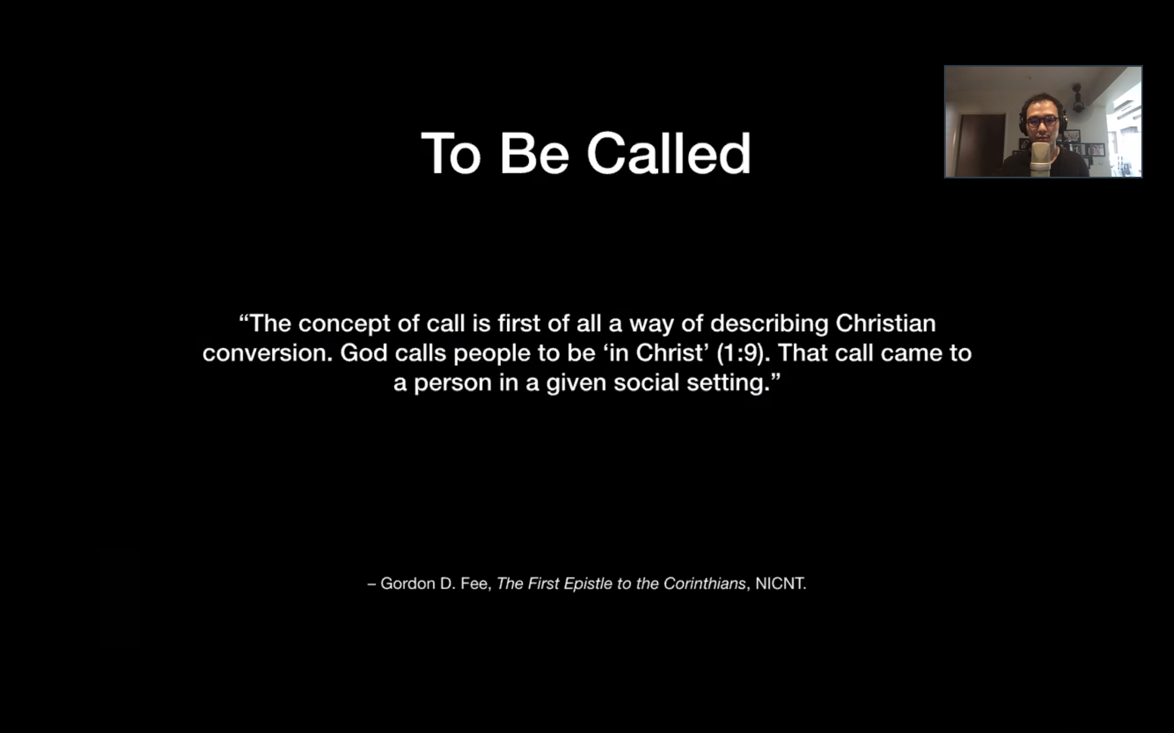

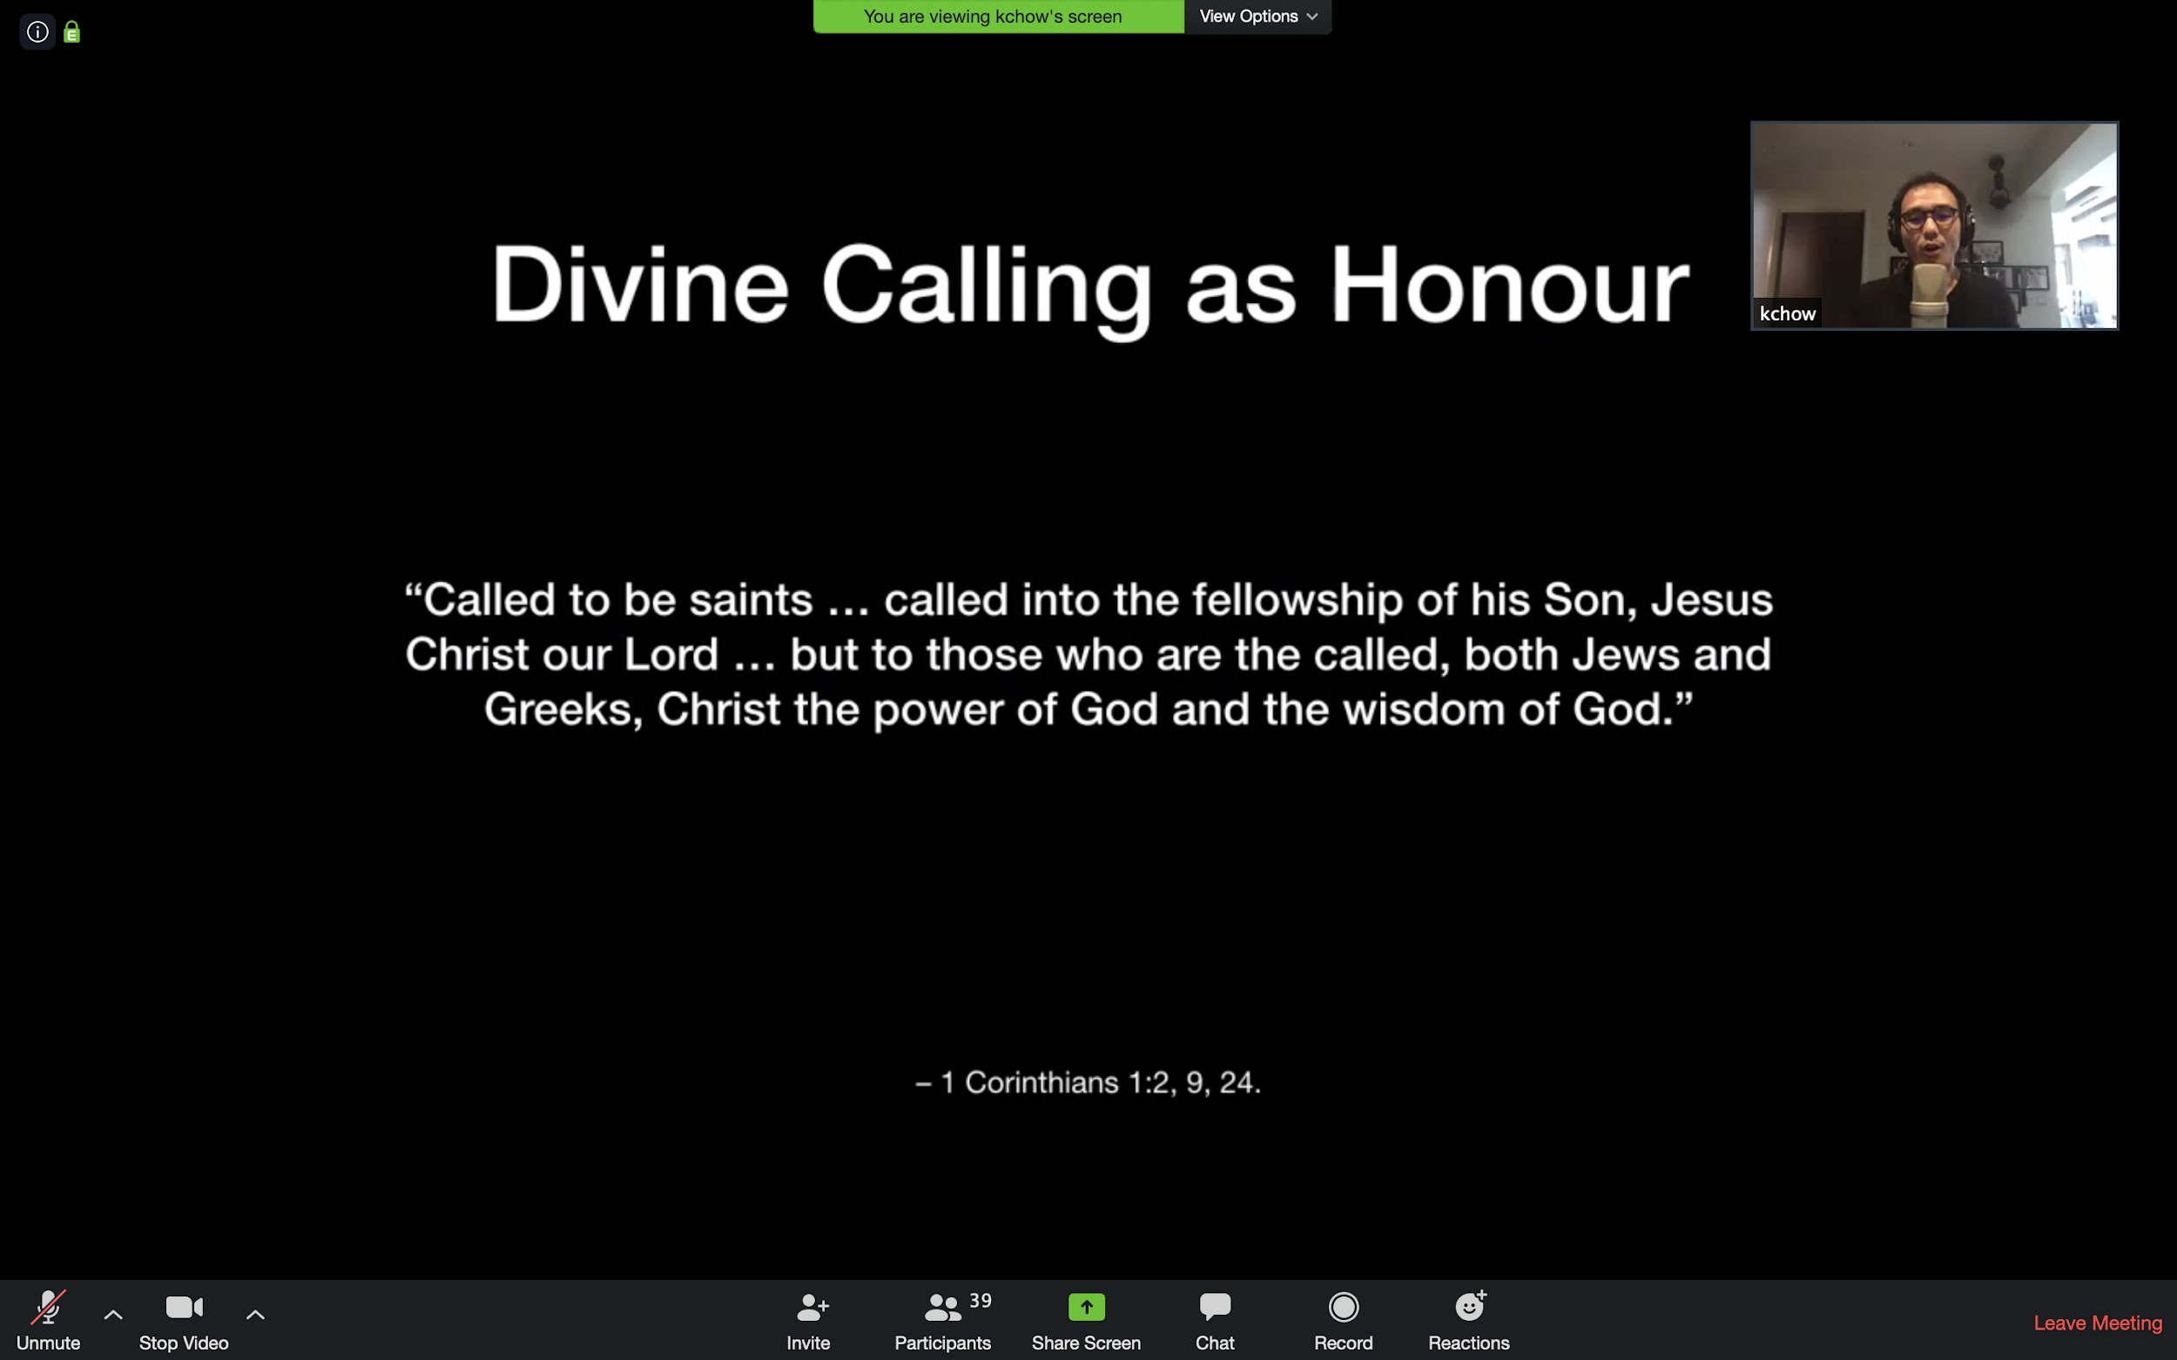

* Honour spills onto you. What more if you are called into fellowship with the Kings of Kings? The wisdom and power of God? You can stop pretending to be the world, you can be who you are meant to be - in fellowship with the Son.
* If your whole life - you are what you can produce, instead of “you are because you belong”, it’s very difficult not to be dissatisfied.

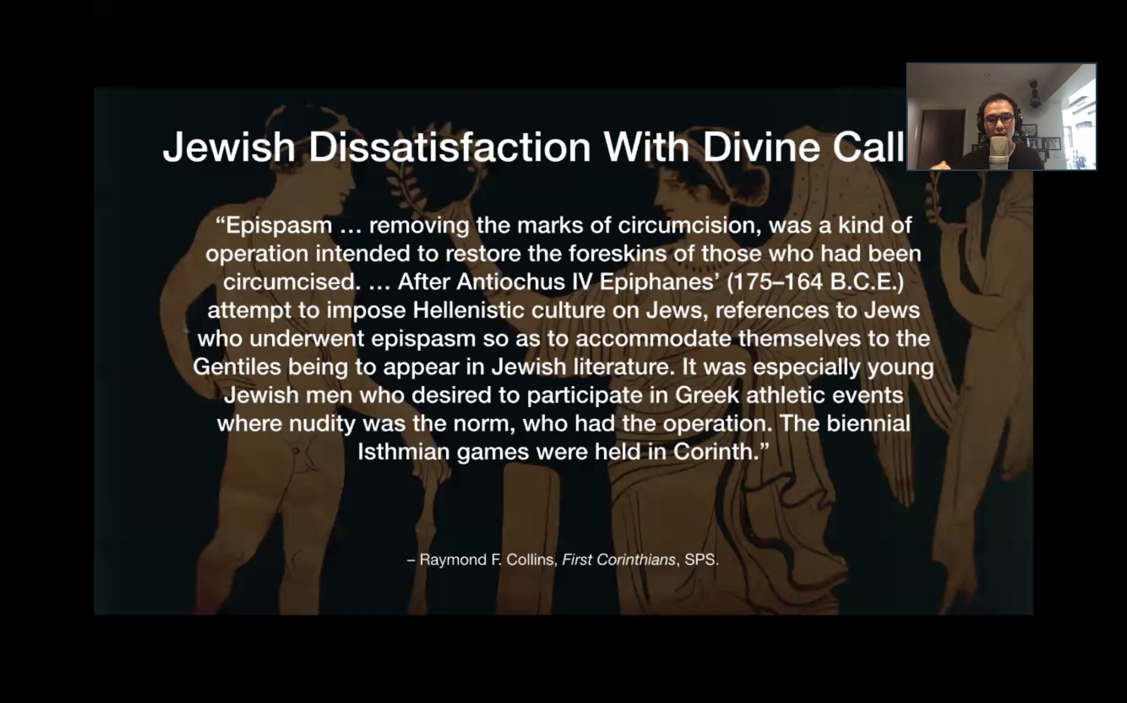

* Removing the mark of circumcision is for a Jew, to deny and reject God.
* The Isthmian games were second to the Olympics. To win would gain one great honour. To participate, one had to be nude.

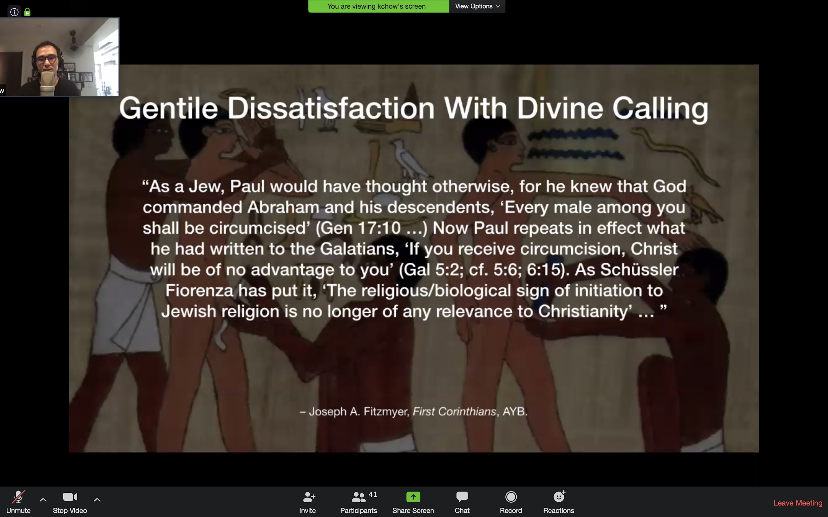

* God’s promise will be fulfilled through the line of Abraham, but you need not bear the mark of circumcision to be in this line - we can now enter this line through Christ.
* They may hold Jewish customs because they thought being more Jewish = being more spiritual.
* But none of these things make you better.

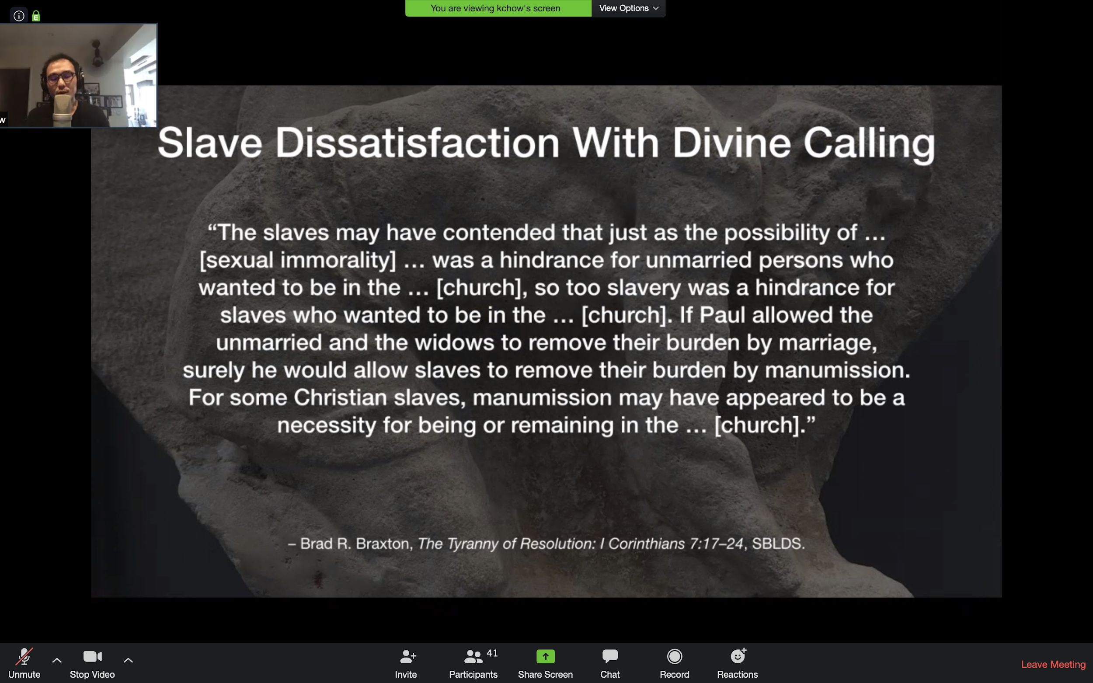

* Slavery was a form of employment in Corinth. You could be a Government official, philosopher, wise teacher.
* The only diff between a slave and freed person is that you are a possession of your master.
* Imagine in your house, your helper shared the gospel with your household.
* What if Chester’s helper wants to worship together? How do we navigate the social dynamics?
* What should the helper do when they come together to worship? Are they equals? How should we see this equality in Christ?
* As a slave, you can set yourself free. You can purchase your freedom with money, or have someone/an institution pay for you.
* Just as sexual immorality is a hindrance, slavery is too. Can I be free from slavery?
* The freeing of slaves (manumission) was a necessity for remaining in the church. They felt that being a slave reduced their honour.
* Relating to a clerk as a cell leader of a CEO, there are weird social implications.

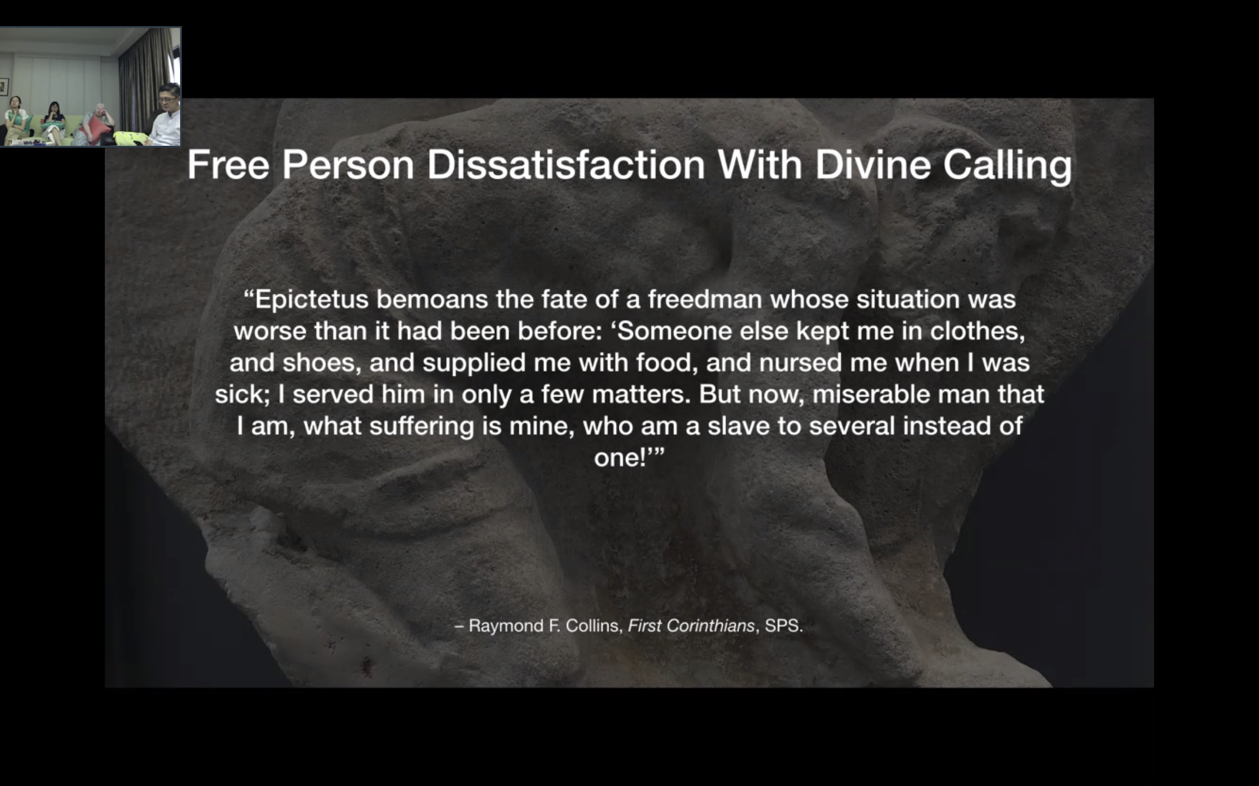

* Maybe you were a good chef or accountant. Previously a slave to master, now

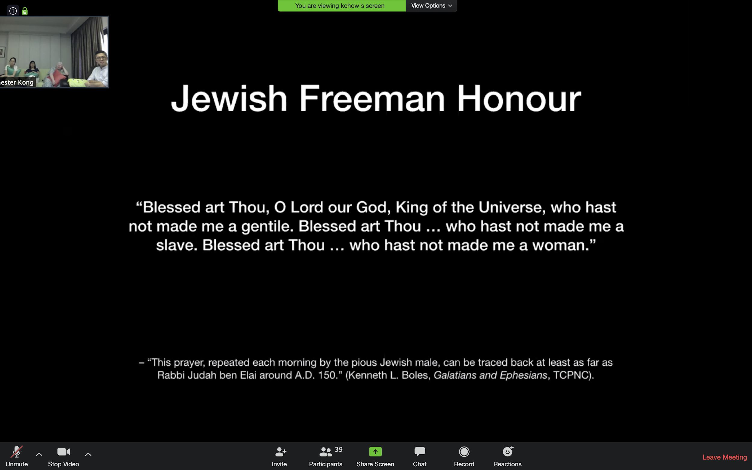

* For a Jew, rejecting the Corinthian’s idea of honour, a gentile, a freed man, a man, is more honourable than the opposite.

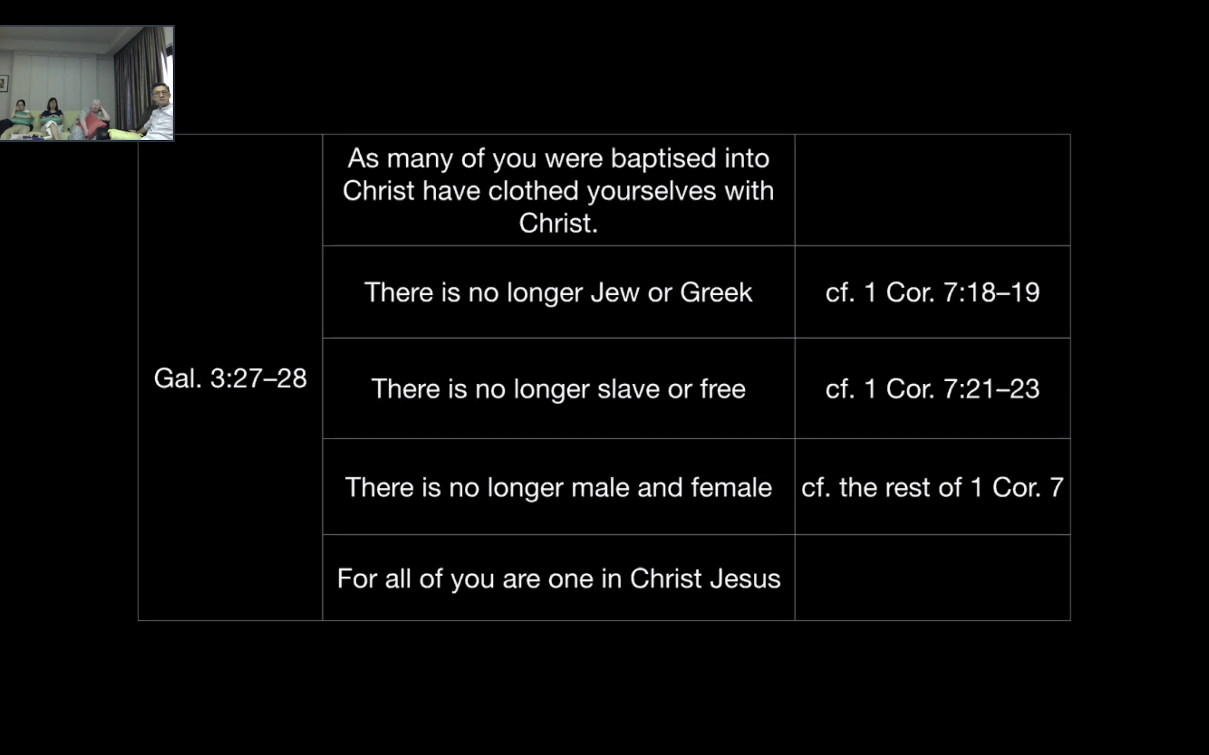

* Paul is asking us to throw away how we gain repute, honour, fame.
* There is a new way of living that is in Christ Jesus.

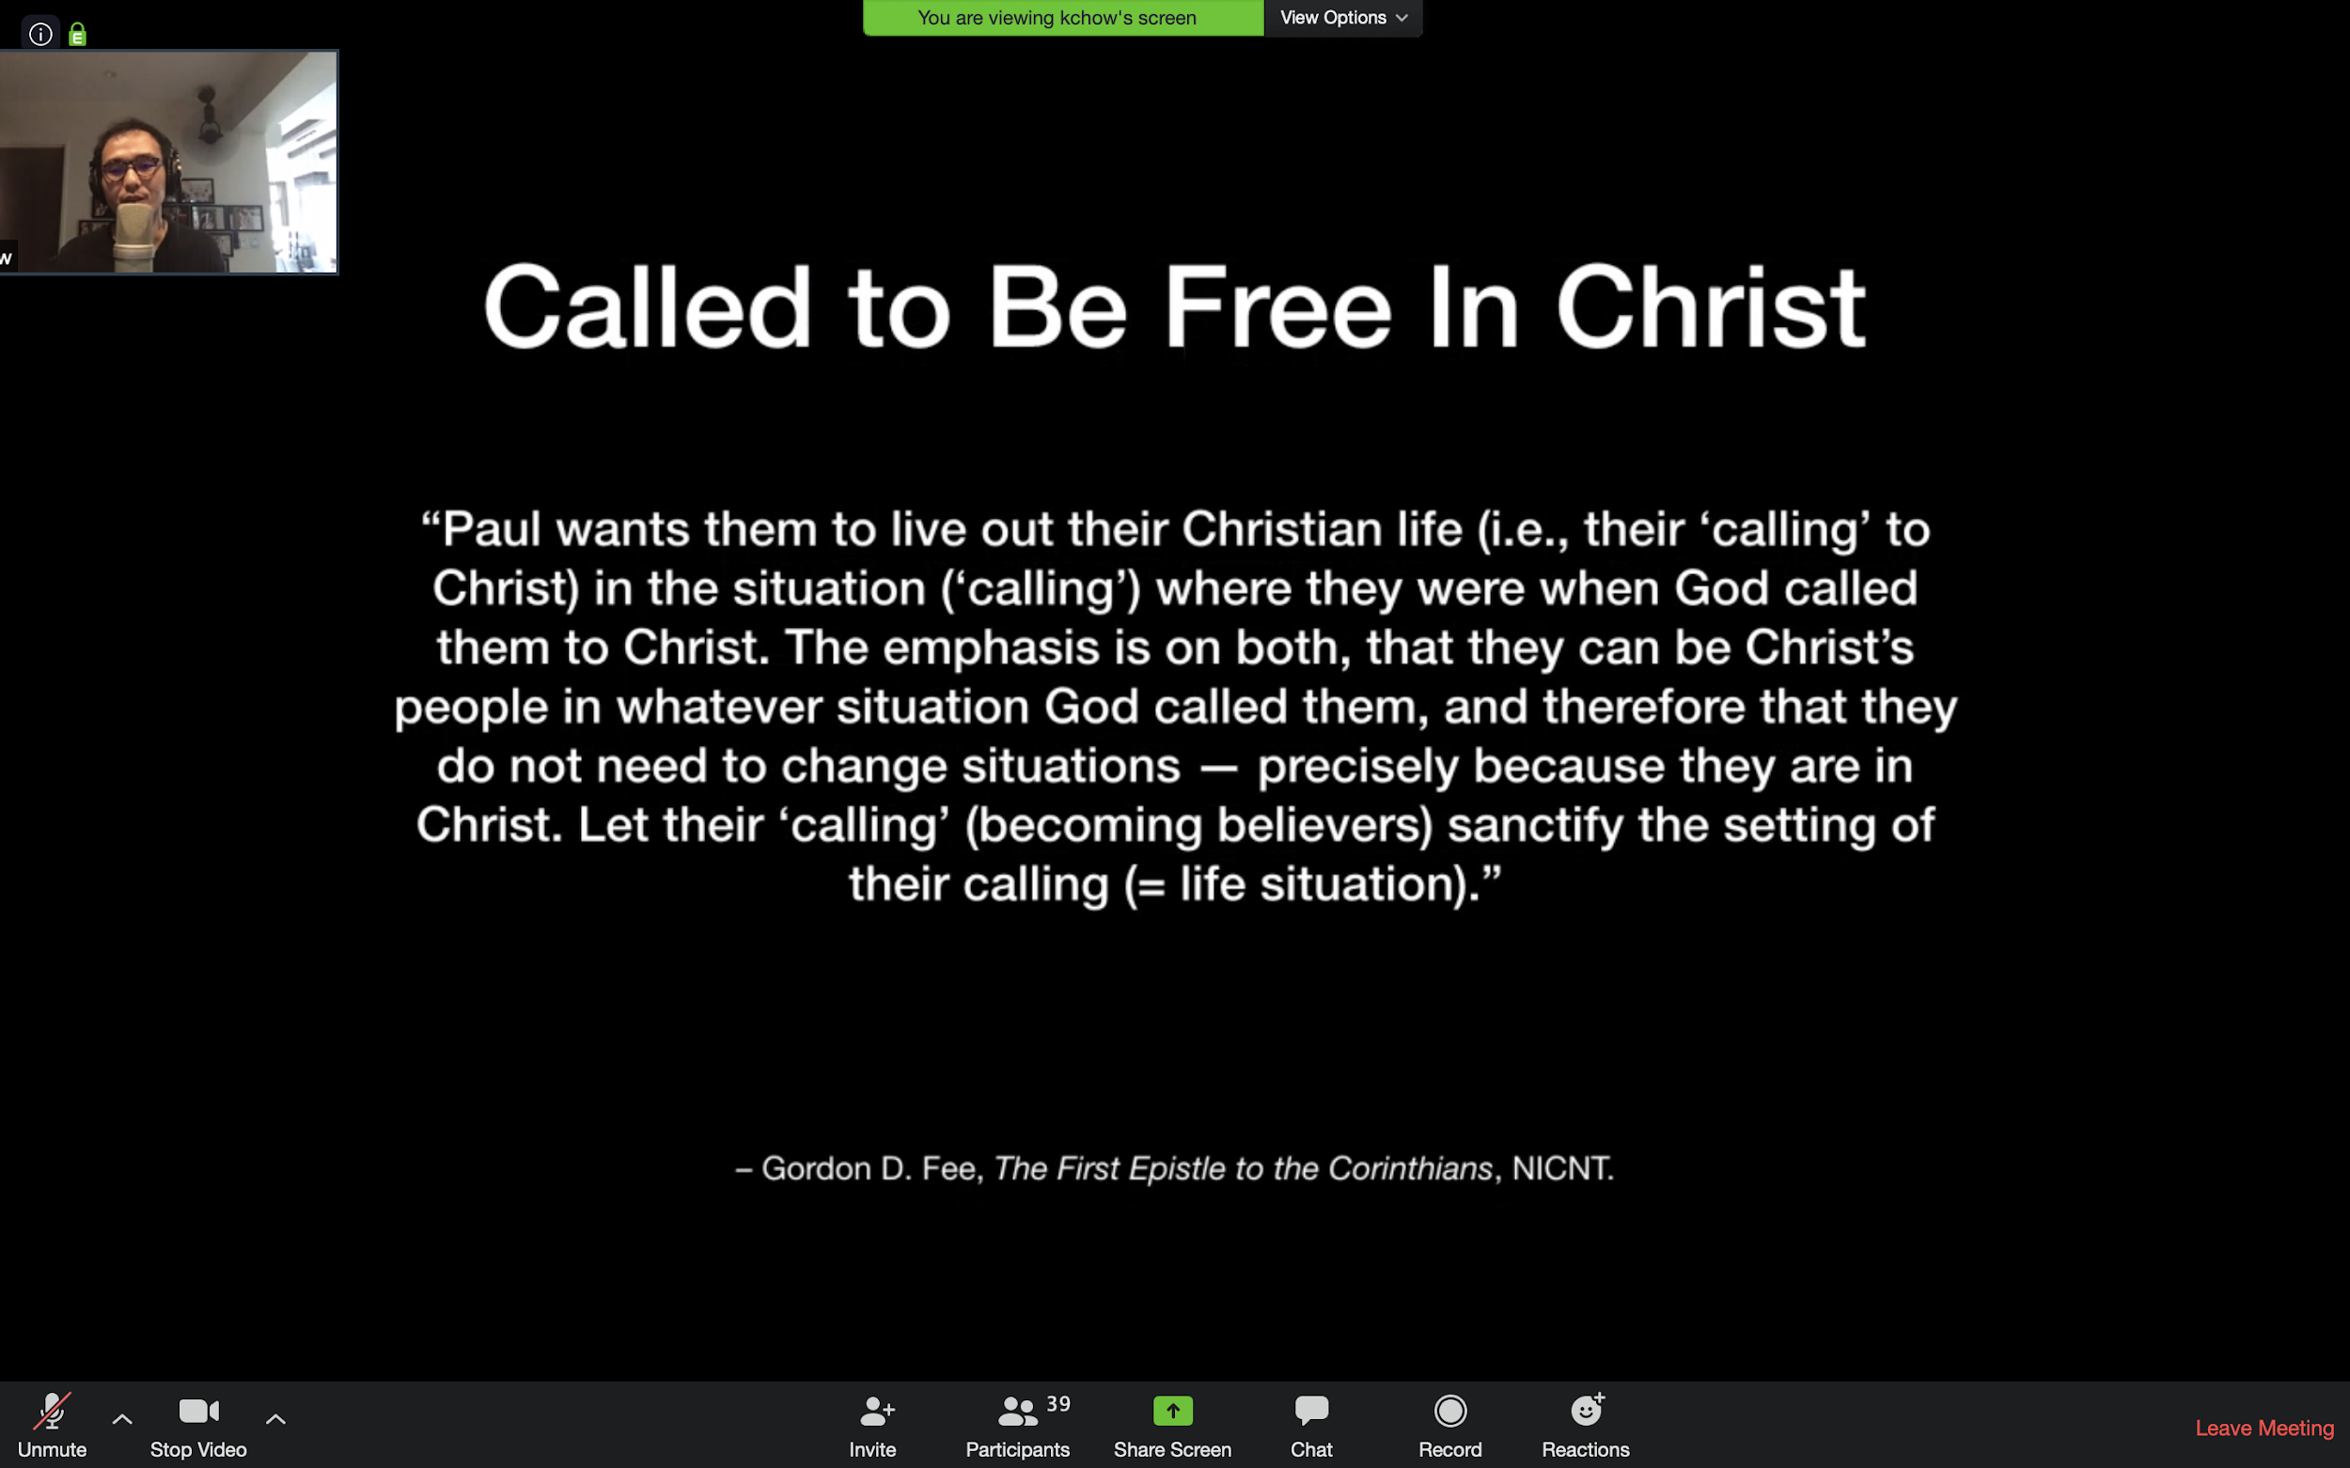

* Are you really so free? You are enslaved to your life circumstances.
* Church camp - my boss cannot give me leave.
* If freedom is circumstancial, we are not really free.
* What does it mean to be more than just being circumstancially free? Paul wants us to live out

1. Our calling in Christ.
2. Our calling in our situation.

* They do not need to change situations because they are in Christ. You can be a slave but free in Christ. You can be a rich person yet enslaved to your wealth.
* Let your calling (your becoming believers) sanctify your calling. We need not seek to actively manipulate or change our situations. We can trust God.

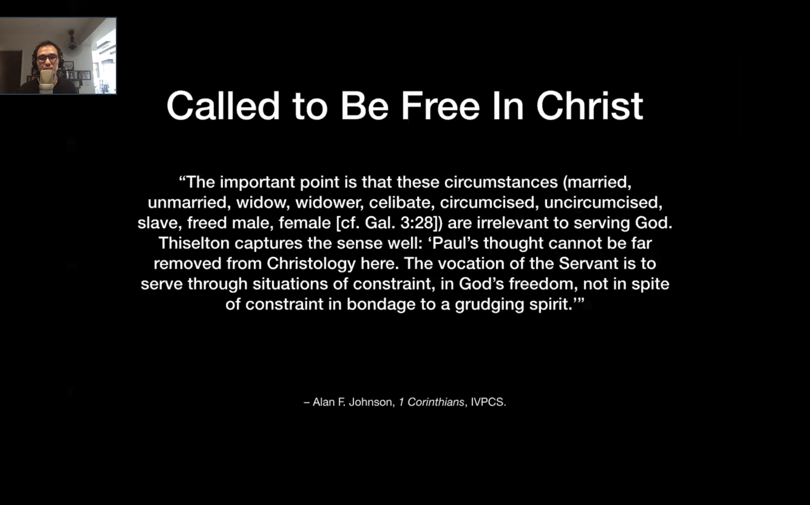

* These circumstances are all irrelevant to serving God.
* I can only be a better Christians if A, B, C, changes.
* I am unmarried, I am a widow, I am a celibate, I am circumcised,



* Does God become a means to serve you instead?

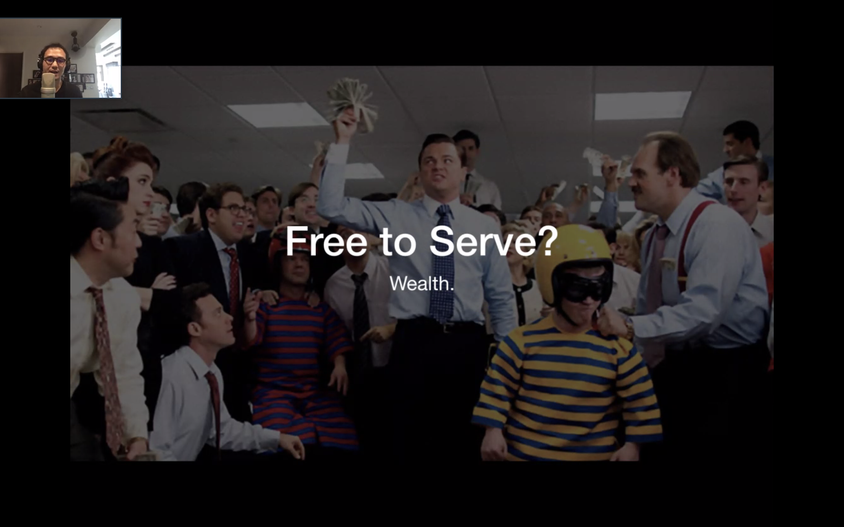

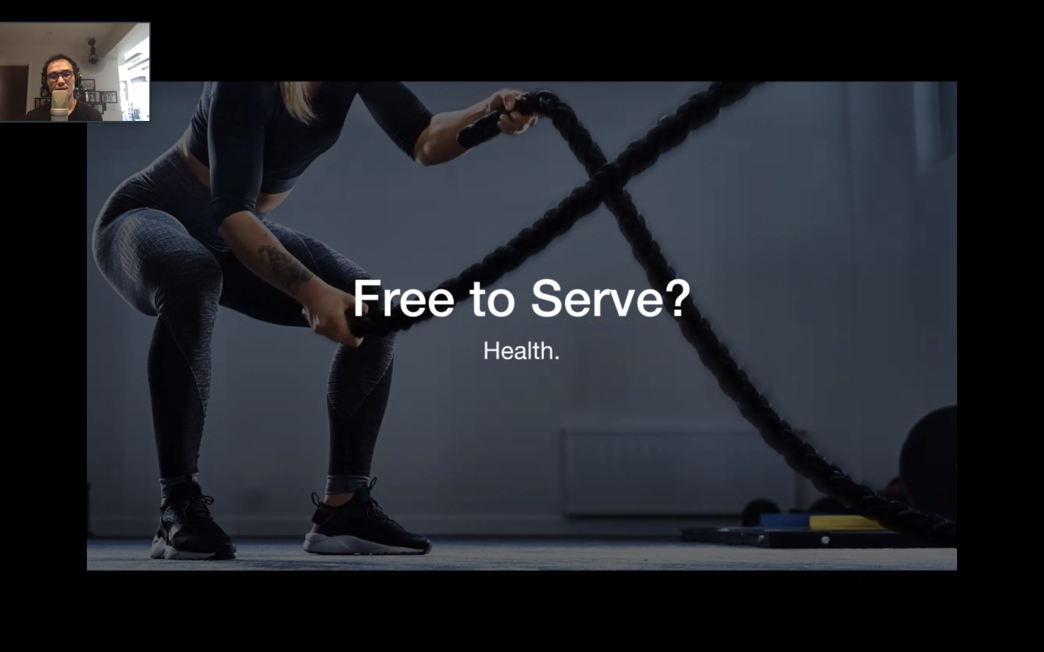

* Uncle Kheng Huat exhibits the call to serve Christ despite life’s constraints.
* It’s not about changing your circumstances so that you can serve God well. It is about serving God in the constraints we are in.

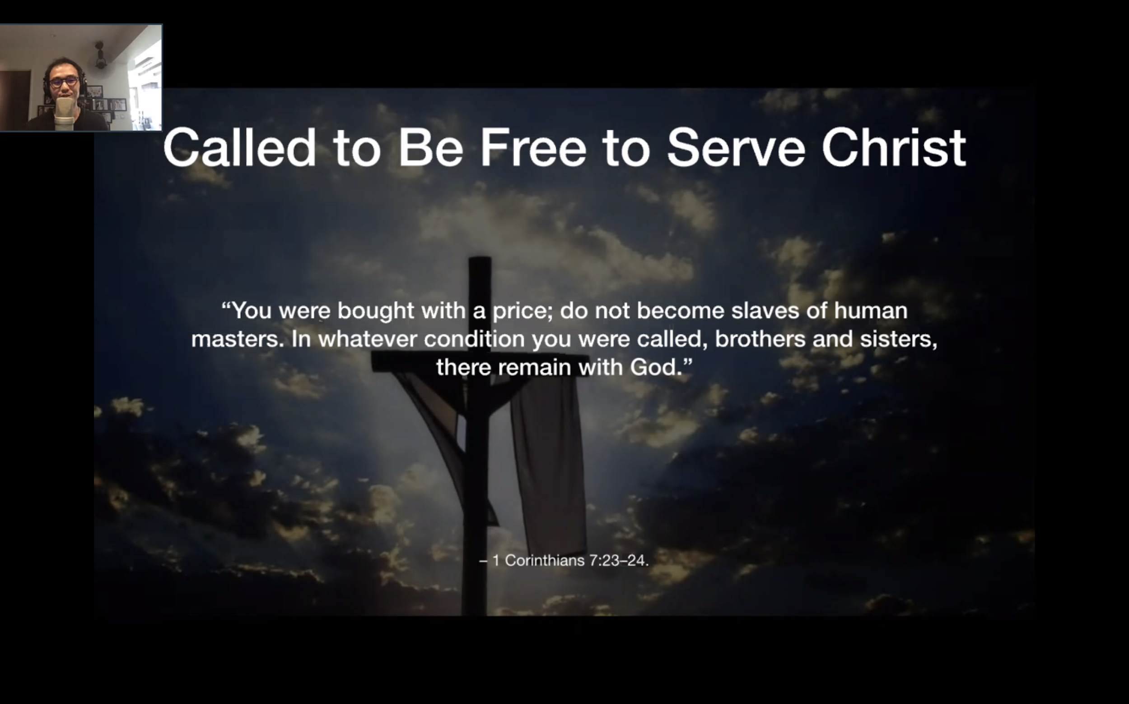

* Let me remind you: you were bought with a price.
* Why are we enslaved to wealth, fear?
* We are either following Christ and being a slave to Christ, or not following Christ and being slaves to sin.

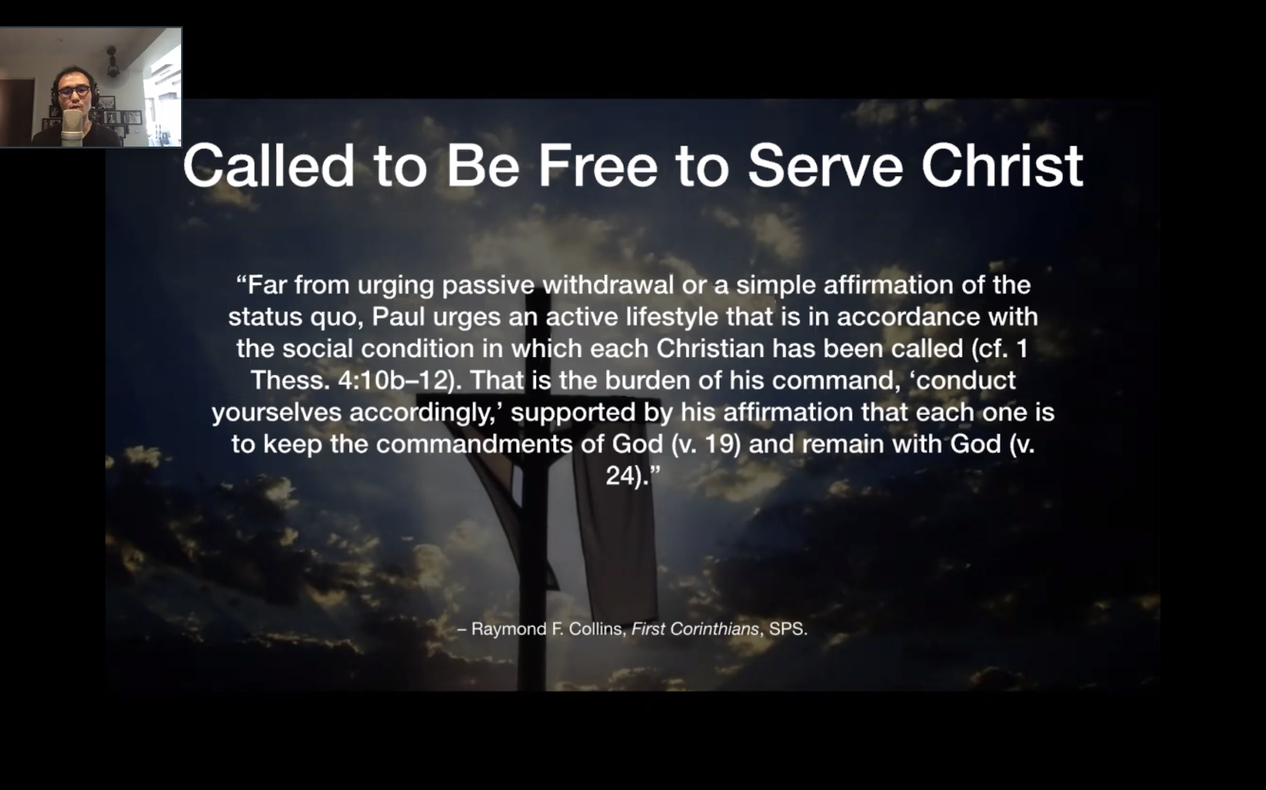

* Not to be garang or super afraid.
* Paul urges an active lifestyle in the conditions in which each Christian has been called.
* It is to keep the commandment of God and remain in him.
* We are still free to serve each other right now. These constraints need not hold us back.

Reflections:

* Which part of your identity hinders you from worshipping God?
* How have I served those around me today?

Questions:

* When it comes to situations which are in the future?
* What about our calling??? What is our calling???

CF:

1. In view of all the lockdowns, how are you feeling?
2. Pray for one another

Ruth:

* Pray for those affected

Tony:

* A test of friendship
* Continue meeting
* Those who are affected